Supplementary material for
Absolute Configuration and Predominant Conformations of 1,1-dimethyl-2-phenylethyl phenyl sulfoxide
Ana G. Petrovicª, Jiangtao Heª, Prasad L. Polavarapuª*, Ling S. Xiao^{b}, and Daniel W. Armstrong^{b}

Table S-1: B3LYP/6-31+G predictions of converged dihedral angles, energies and relative populations of the four minimum-energy conformers of 1.

6-31+G | Converged Dihedral Angles^{b}
Conformersª | D(2,3,12,13) | D(3,12,13,22) | D(12,13,22,30) | D(13,22,30,25) | Gibbs Energies^{c} | Fractional  Population
G⁺T | 85.7 | 59.1 | 168.8 | -93.8 | -1093.717477 | 0.41
TG⁺ | 85.6 | 169.3 | 62.8 | -92.7 | -1093.716819 | 0.21
TT | 86.8 | 177.0 | -178.9 | -90.7 | -1093.716792 | 0.20
G⁻T | 88.0 | -65.5 | -171.2 | -88.3 | -1093.716704 | 0.18

ªT, G⁺ and G⁻ represent anti, plus gauche and minus gauche conformers. The first letter represents the conformation around bond B and the second letter around bond C. See Figures 1-3.
^{b}D stands for dihedral angle in degrees. The numbers inside of the parentheses indicate atom-numbers as shown in Figure 1.
^{c}in Hartrees

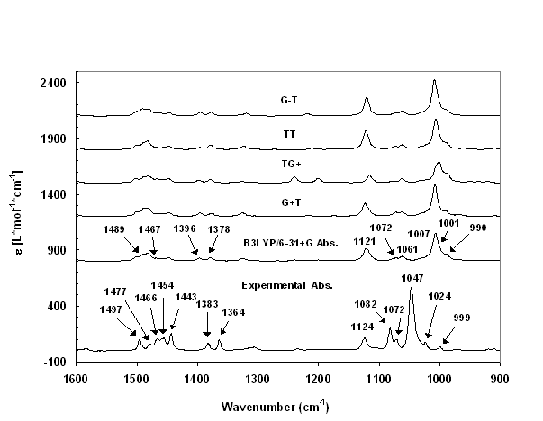

Figure S-1: B3LYP/6-31+G calculated vibrational absorption spectra for four conformers (top four traces), population weighted predicted absorption spectrum of 1,1-dimethyl-2-phenylethyl phenyl sulfoxide and experimental (bottom trace, 0.1355M in CCl₄ solvent; path length 200 μm) absorption spectrum of 1,1-dimethyl-2-phenylethyl phenyl sulfoxide. Lorentzian band shapes and 5 cm⁻¹ half-width (at half-peak height) were used in spectral simulation; Calculated frequencies were scaled by 0.9899.

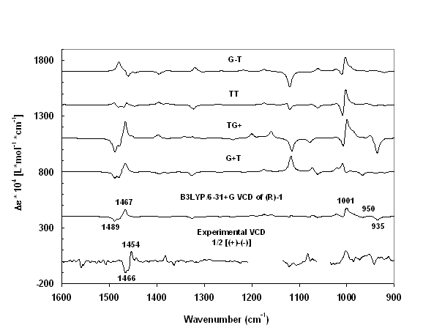

Figure S-2: B3LYP/6-31+G calculated VCD spectra for four conformers (top four traces), population weighted predicted VCD spectrum of (R)-1,1-dimethyl-2-phenylethyl phenyl sulfoxide and experimental (bottom trace, 0.1355M in CCl₄ solvent; path length 200 μm) VCD spectrum of (+)-1,1-dimethyl-2-phenylethyl phenyl sulfoxide. Lorentzian band shapes and 5 cm⁻¹ half-width (at half-peak height) were used in spectral simulation; Calculated frequencies were scaled by 0.9899.

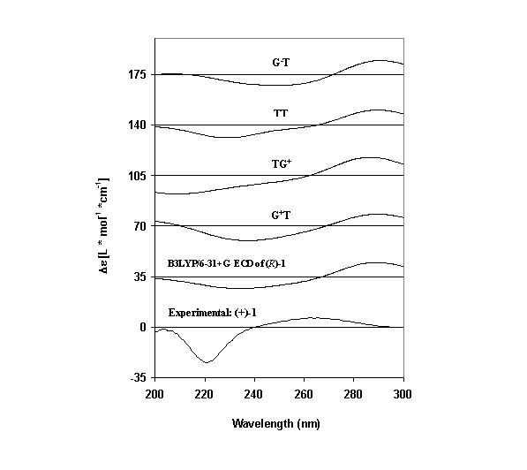

Figure S-3: B3LYP/6-31+G calculated ECD spectra for four conformers (top four traces), population weighted predicted ECD spectrum of (R)-1,1-dimethyl-2-phenylethyl phenyl sulfoxide and experimental (bottom trace) ECD spectrum of (+)-1,1-dimethyl-2-phenylethyl phenyl sulfoxide. The experimental ECD intensities presented in this figure were scaled up by a factor of six. Gaussian band shapes and 20 nm half-width (at 1/e of peak height) were used to simulate the predicted spectra.

Table S-2: B3LYP/6-311G(2d,2p) predictions of converged dihedral angles, energies and relative populations of the four minimum-energy conformers of 1.

6-311G(2d,2p) | Converged Dihedral Angles^{b}
Conformersª | D(2,3,12,13) | D(3,12,13,22) | D(12,13,22,30) | D(13,22,30,25) | Gibbs Energies^{c} | Fractional  Population
G⁺T | 85.2 | 60.5 | 168.6 | -94.2 | -1093.906587 | 0.48
TG⁺ | 85.7 | 170.1 | 62.6 | -92.4 | -1093.905582 | 0.17
TT | 86.3 | 178.0 | -177.9 | -90.8 | -1093.905665 | 0.18
G⁻T | 87.5 | -65.1 | -171.1 | -88.0 | -1093.905606 | 0.17

ªT, G⁺ and G⁻ represent anti, plus gauche and minus gauche conformers. The first letter represents the conformation around bond B and the second letter around bond C. See Figures 1-3.
^{b}D stands for dihedral angle in degrees. The numbers inside of the parentheses indicate atom-numbers as shown in Figure 1.
^{c}in Hartrees

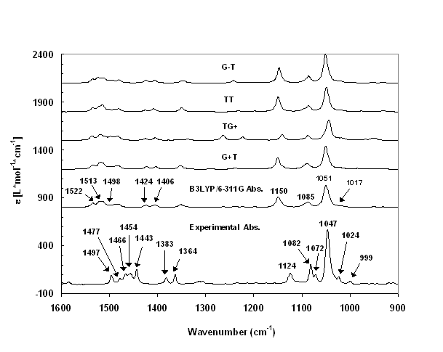

Figure S-4: B3LYP/6-311G(2d,2p) calculated vibrational absorption spectra for four conformers (top four traces), population weighted predicted absorption spectrum of 1,1-dimethyl-2-phenylethyl phenyl sulfoxide and experimental (bottom trace, 0.1355M in CCl₄ solvent; path length 200 μm) absorption spectrum of 1,1-dimethyl-2-phenylethyl phenyl sulfoxide. Lorentzian band shapes and 5 cm⁻¹ half-width (at half-peak height) were used in spectral simulation. Calculated frequencies were not scaled.

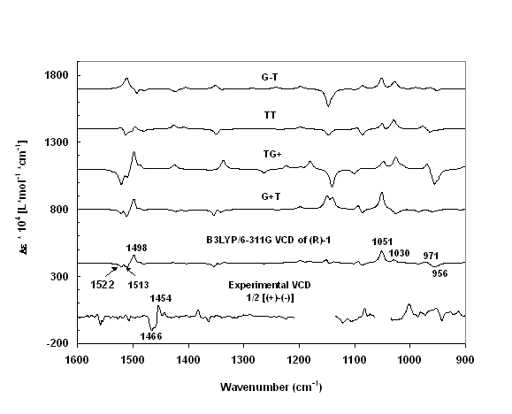

Figure S-5: B3LYP/6-311G(2d,2p) calculated VCD spectra for four conformers (top four traces), population weighted predicted VCD spectrum of (R)-1,1-dimethyl-2-phenylethyl phenyl sulfoxide and experimental (bottom trace, 0.1355M in CCl₄ solvent; path length 200 μm) VCD spectrum of (+)-1,1-dimethyl-2-phenylethyl phenyl sulfoxide. Lorentzian band shapes and 5 cm⁻¹ half-width (at half-peak height) were used in spectral simulation. Calculated frequencies were not scaled.

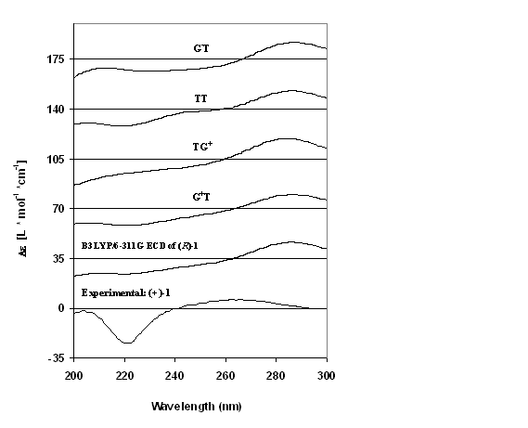

Figure S-6: B3LYP/6-311G(2d,2p) calculated ECD spectra for four conformers (top four traces), population weighted predicted ECD spectrum of (R)-1,1-dimethyl-2-phenylethyl phenyl sulfoxide and experimental (bottom trace) ECD spectrum of (+)-1,1-dimethyl-2-phenylethyl phenyl sulfoxide. The experimental ECD intensities presented in this figure were scaled up by a factor of six. Gaussian band shapes and 20 nm half-width (at 1/e of peak height) were used to simulate the predicted spectra.

